Day 32 - 03rd Sept 2025

Task 1:

Create a table with few attributes..
Also add some records..
Take a ss of it and paste it

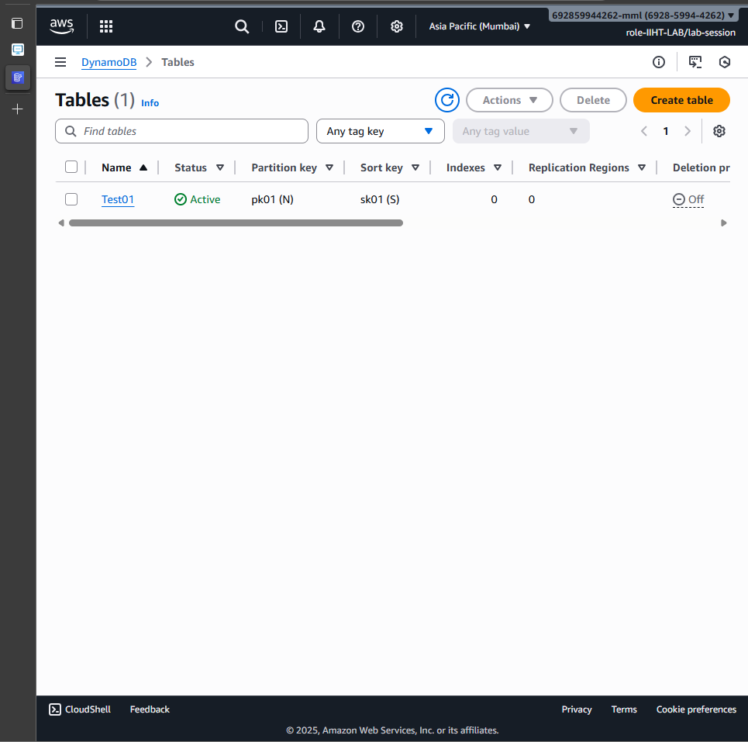
Task 2:

Create a table and do the crud operations on the table ..
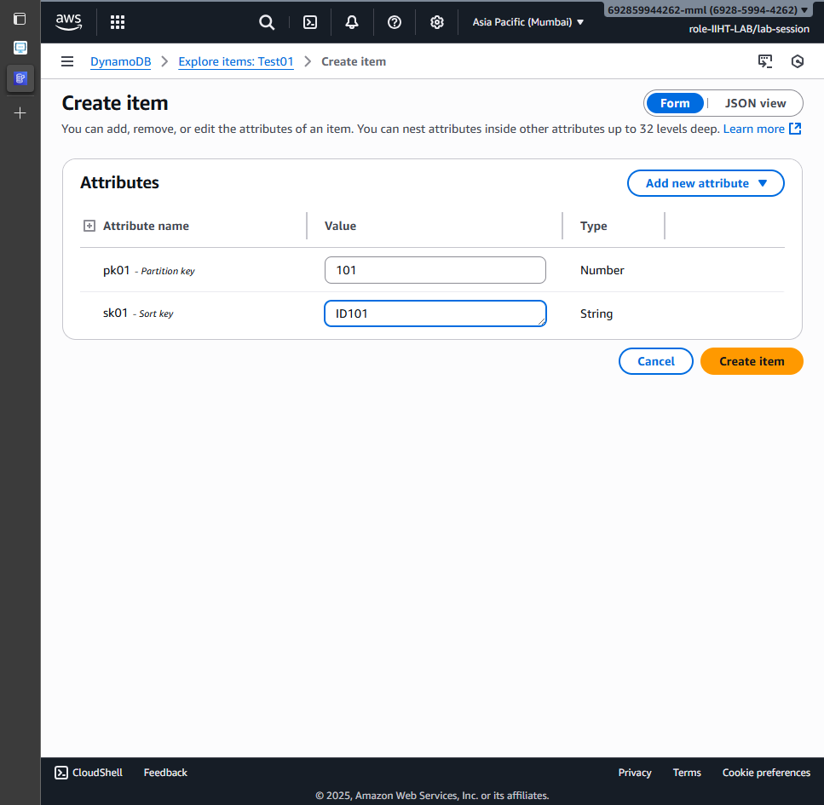

CRUD operations in AWS Dynamodb CLI:

Creating a table

aws dynamodb create-table --table-name Employee --attribute-definitions AttributeName=ID,AttributeType=N AttributeName=EmpName,AttributeType=S --key-schema AttributeName=ID,KeyType=HASH AttributeName=EmpName,KeyType=RANGE --provisioned-throughput ReadCapacityUnits=5,WriteCapacityUnits=5

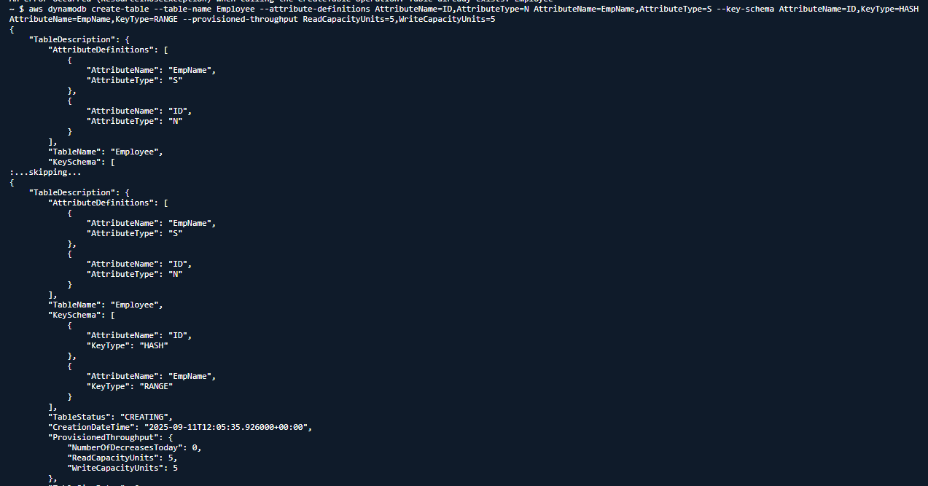

configuring AWS CLI
install aws cli - aws cli
configure aws cli
aws configure

aws access key
secret key
region and output format

IAM permissions:

IAM user or role

CreateTable
PutItems
Getitems
Query
UpdateItems
DeleteItems
DeleteTable
---------------------------------------------------------------
Add custom IAM policy

aws iam create policy \
--policy-name
DynamoDBManagementPolicy \
--policy-document '{"Version" : "2025-05-20",
"Statement" :
[ {"Effect": "Allow", "Action" :
["dynamodb: CreateTable",
"dynamodb: Query", .......],
"Resource": "*" } ] }'

the above policy lets give to a role/user

aws iam attach-user-policy --policy-arn arn:aws:iam:: DynamoDBManagementPolicy
--user-name emp(here give the username for whom your want to attach the above policy)

create table
insert data
crud operAtions

---- GUI , CLI, SDK...

insert into table

aws dynamodb put-item --table-name Employee --item '{"ID": {"N": "1001"}, "EmpName": {"S": "AjayKumar"} }'

aws dynamodb put-item --table-name Employee --item '{"ID": {"N": "1001"},
"EmpName": {"S": "VijayKumar"} }'
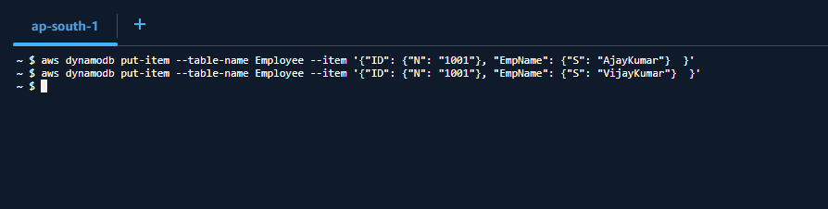

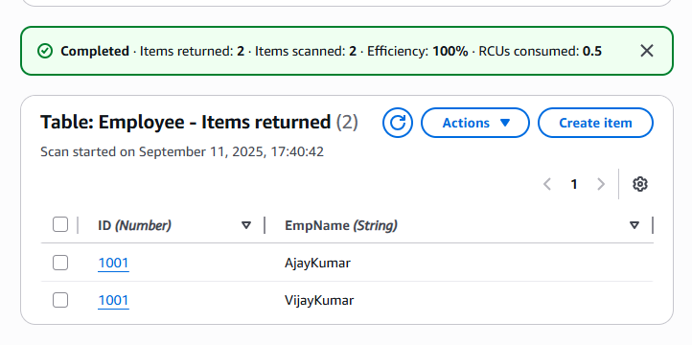

Query:

aws dynamodb query --table-name Employee
--key-condition-expression "ID = :ID"
--expression-attribute-values '{":ID":{"N":"1001"}}'

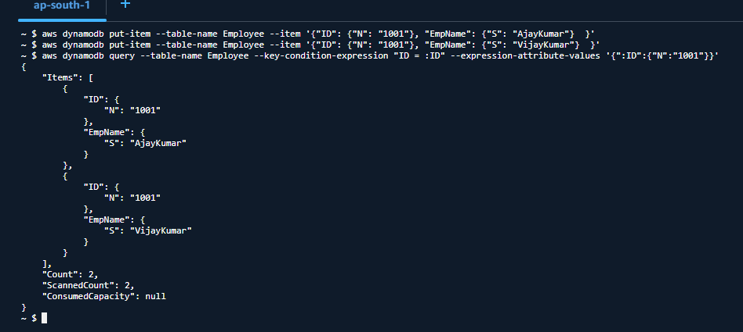

Update:

aws dynamodb update-item --table-name Employee
--key '{"ID": {"N": "1001"} , "EmpName": {"S": "AjayKumar"} }'
--update-expression "set info = :info"
--expression-attribute-values '{":info": {"S": "Kadiyala"}}'
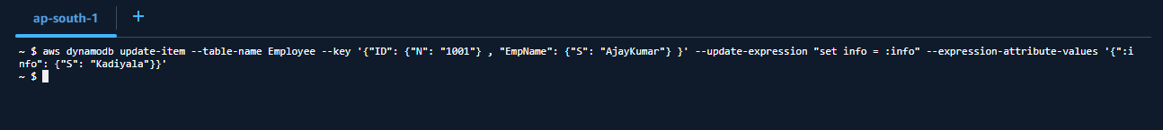
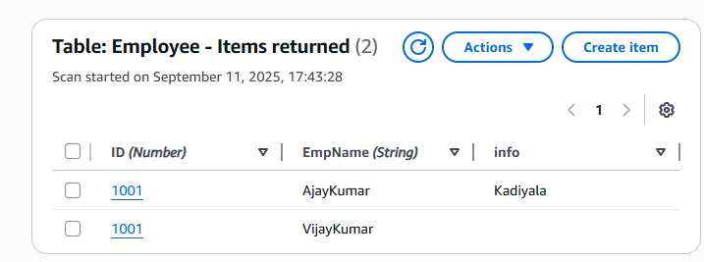

Delete :

aws dynamodb delete-item --table-name Employee
--key '{"ID": {"N": "1001"}, "EmpName":{"S": "VijayKumar"} }'
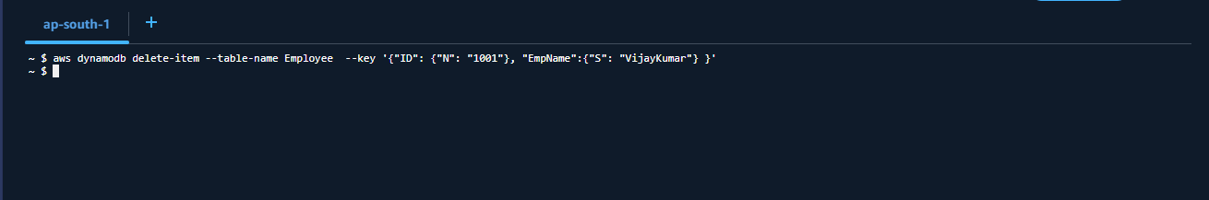
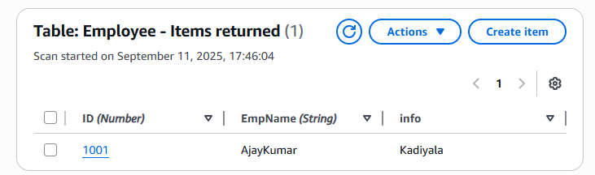

List the tables

Aws dynamodb list-tables

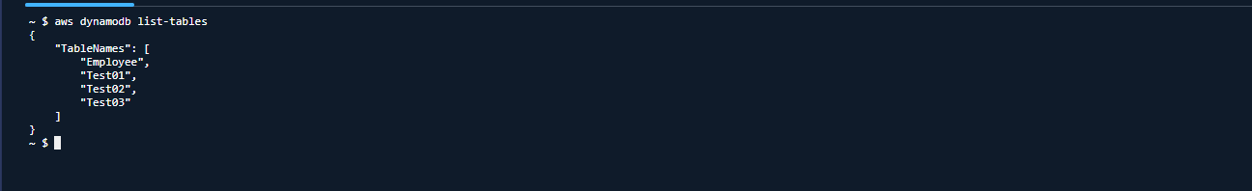

detailed info about our table
aws dynamodb describe-table --table-name Employee

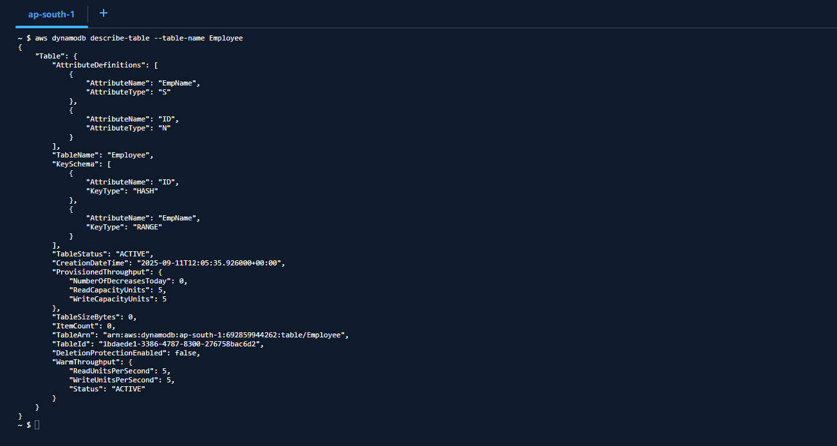
Scan the table
aws dynamodb scan --table-name Employee

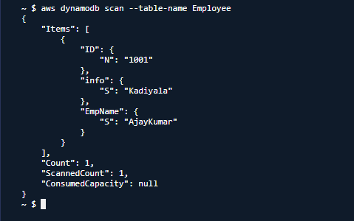
aws sts get-caller-identity
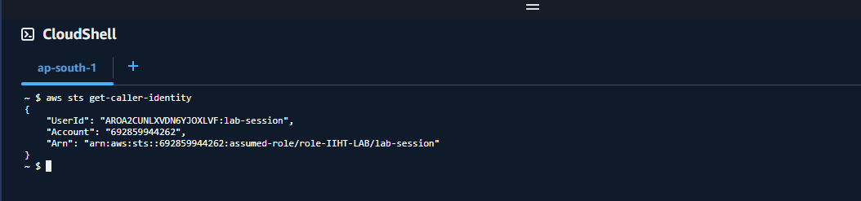
aws - - version

Creating a table using wizard
aws dynamodb wizard new-table

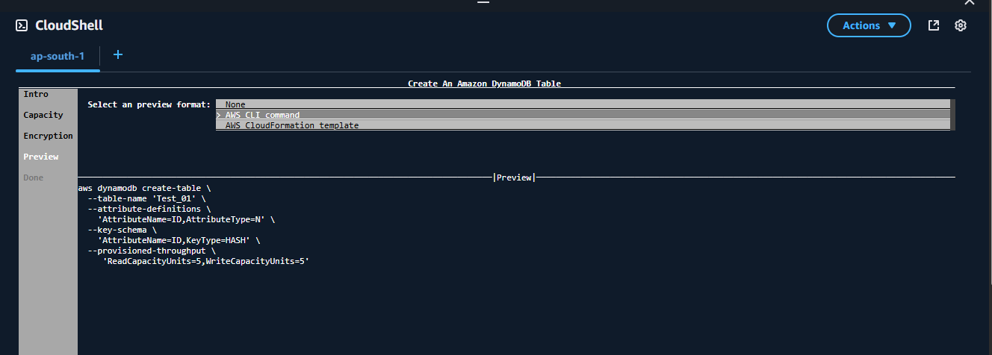
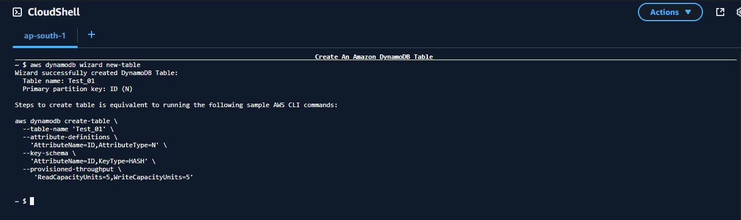

taking backup of a table
aws dynamodb create-backup
--table-name Employee
--backup-name MyEmployeebackup
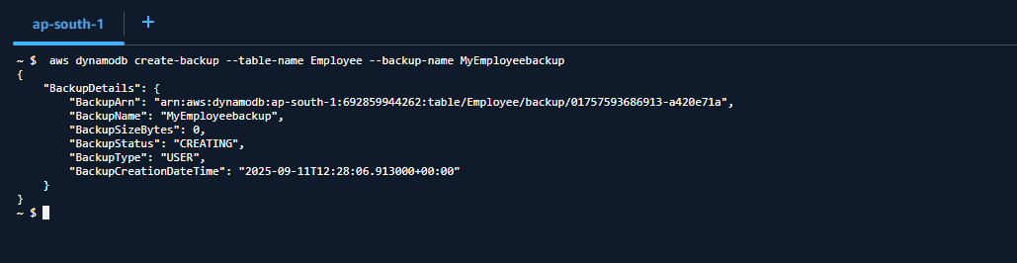
Listing all the backup files

aws dynamodb list-backups

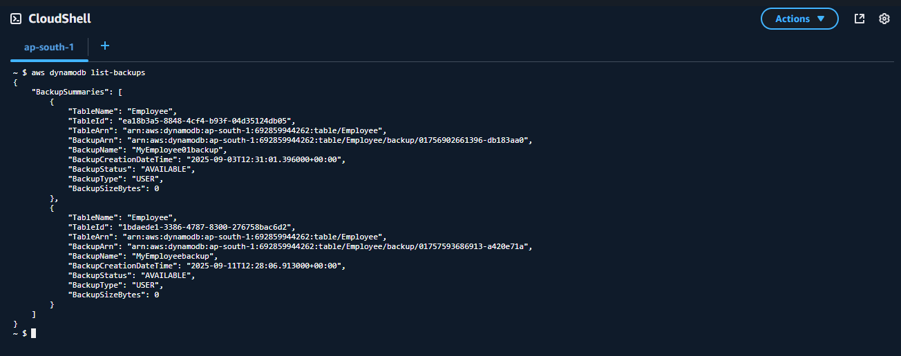

Deacribing back up table

aws dynamodb describe-backup --backup-arn arn:aws:dynamodb:ap-south-1:692859944262:table/Employee/backup/01757593686913-a420e71a

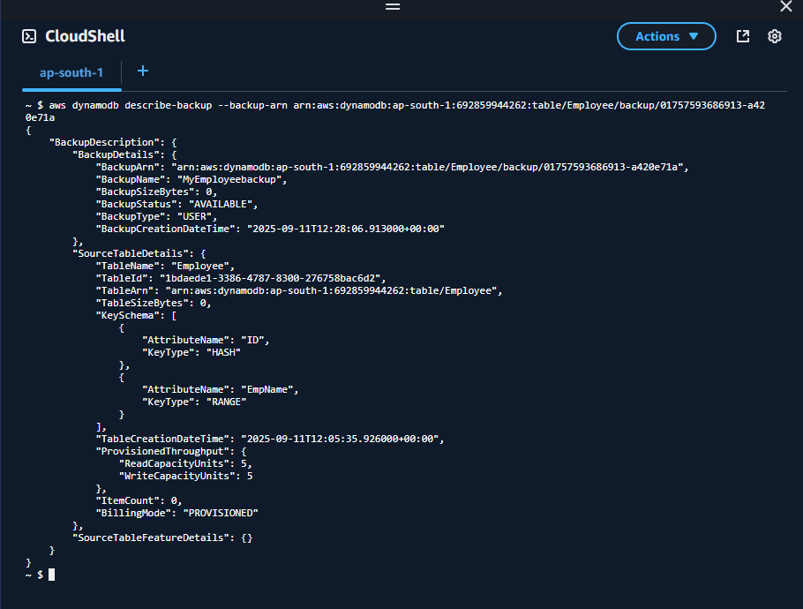

Restoring table from back up file

Using ARN

aws dynamodb restore-table-from-backup --target-table-name restoreEmpoloyee01 --backup-arn arn:aws:dynamodb:ap-south-1:692859944262:table/Employee/backup/01757593686913-a420e71a

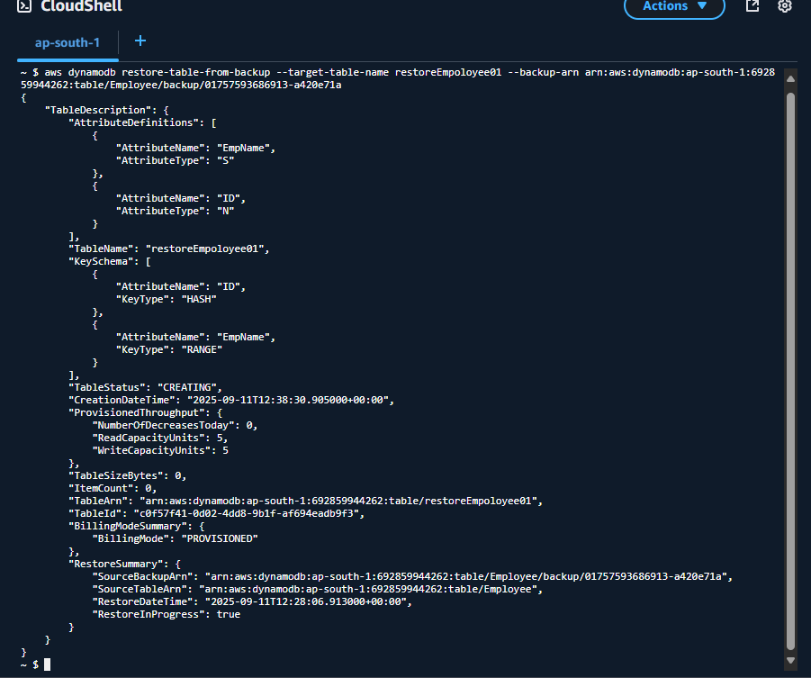

Check for the restore file… using list-tables command
aws dynamodb list-tables
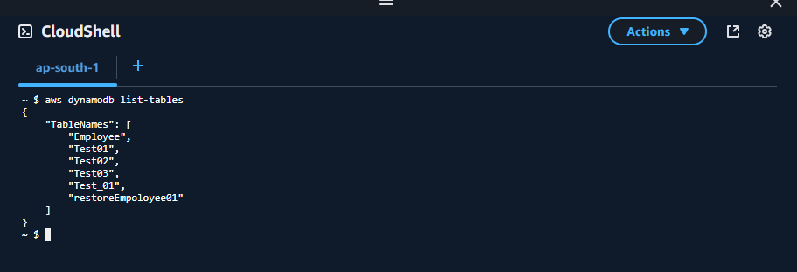

Info Box:

Project doc link.. ALL Projects 10 Day plan

https://docs.google.com/document/d/1gOzEONAVHm-DifF-RhEy_PwsdjCnkLzi/edit?usp=sharing&ouid=103020917863623365252&rtpof=true&sd=true

Batch 1 projects

https://docs.google.com/spreadsheets/d/16Ia3jG_uJtTPvpDQTv-XW3-0OE1qagjD5pgB9TYcKDc/edit?usp=sharing

